28. Design a wireframe in Figma for a multimedia-rich mobile app, incorporating elements from both Core Video and Core Media frameworks.

Aim:Design a wireframe for a multimedia-rich mobile app, incorporating elements from both Core Video and Core Media frameworks using figma

Procedure:
- Open Figma
- Create a new file
- Select the Frames
- Design Visual Elements
- Make it Interactive
- Add icons on the Frame
- Incorporate Multimedia
- Storyboard Animation
- Review and edit the Prototype
- Save and Share

Design:
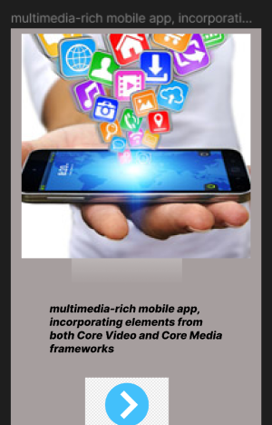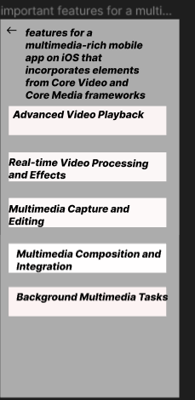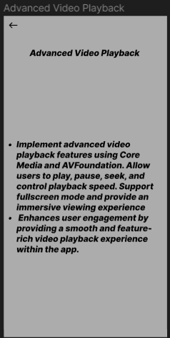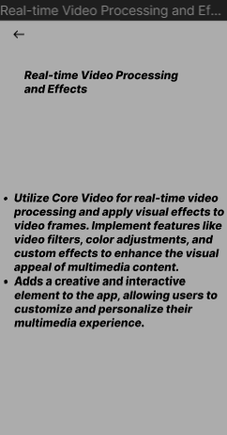

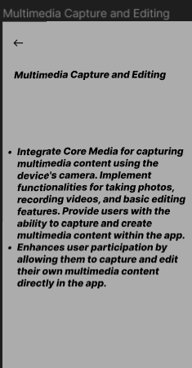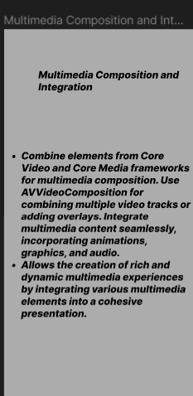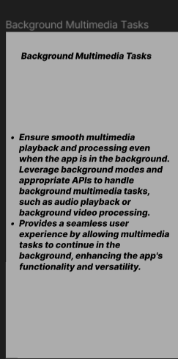

Prototype:
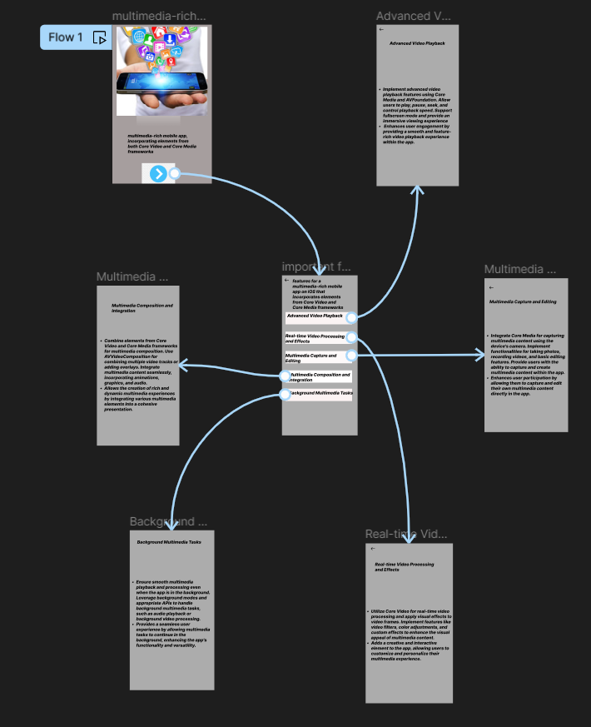
Result: A wireframe for a multimedia-rich mobile app, incorporating elements from both Core Video and Core Media frameworks using figma have been created successfully

